# Introduction

This tutorial describes an easiest method to download your vkontakte ego-graph. It only works for Windows. If you are a Mac user, please try to get access to Windows machine to download your graph (good news is that after you get your graph, you can do the homework on your Mac computer). An alternative is to use VK application-programming interface (API), but this method is much more sophisticated and we do not recommend it within this course. If you feel like trying the API method, you can always Google how to do it.

# 1. Download NodeXL

You will need to download and install NodeXL template for Microsoft Excel, if you do not have it already. Go to <http://nodexl.codeplex.com/releases/view/117659>.

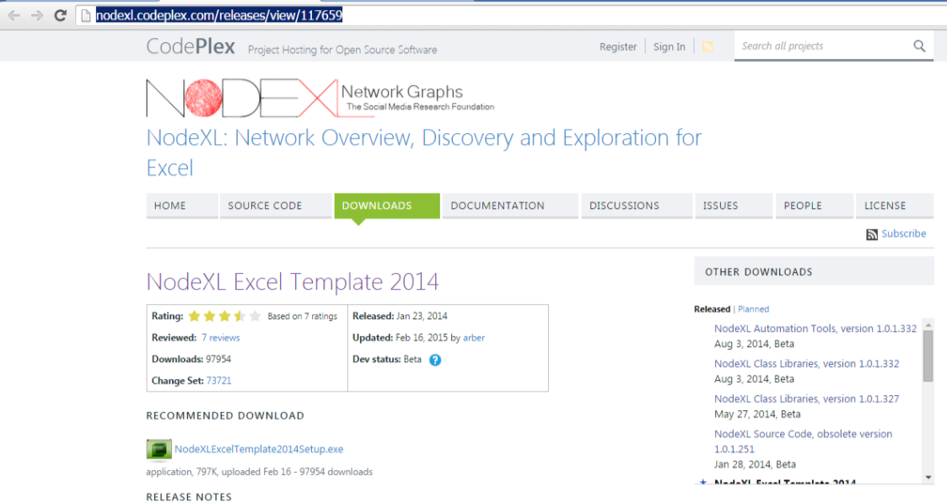

Download and run an .exe file. Go through the installer.

# 2. Download RuNet Importer for NodeXL

* Download zip archive from <https://runetimporter.codeplex.com/releases>

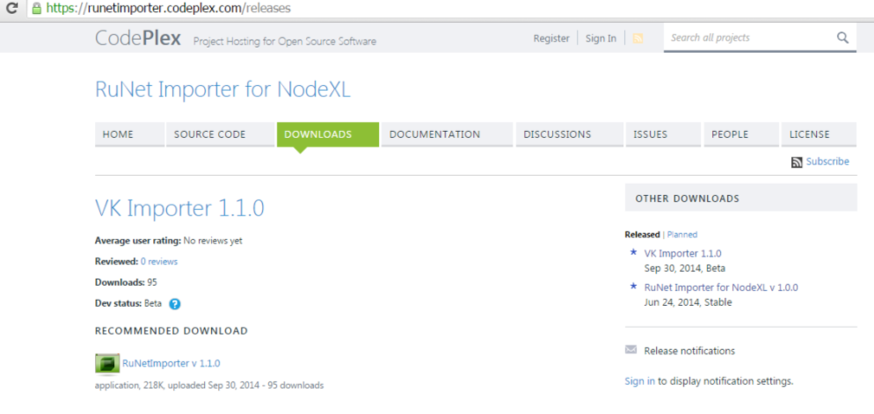

* Unzip the archive – create a folder with 4 .dll files:

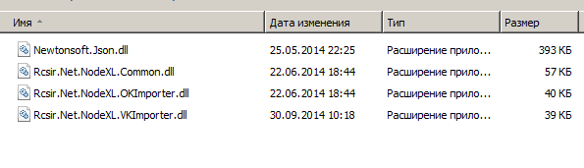

* Start or restart NodeXL:



You should see the NodeXL starting window:

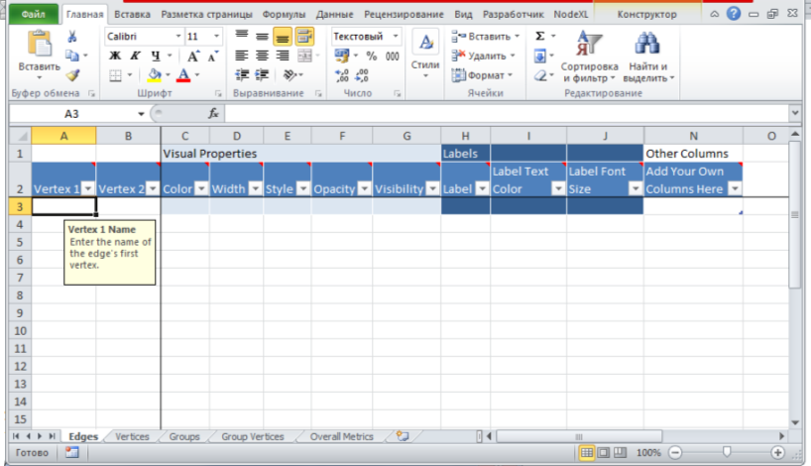

• Go to NodeXL -> Import -> Import Options:

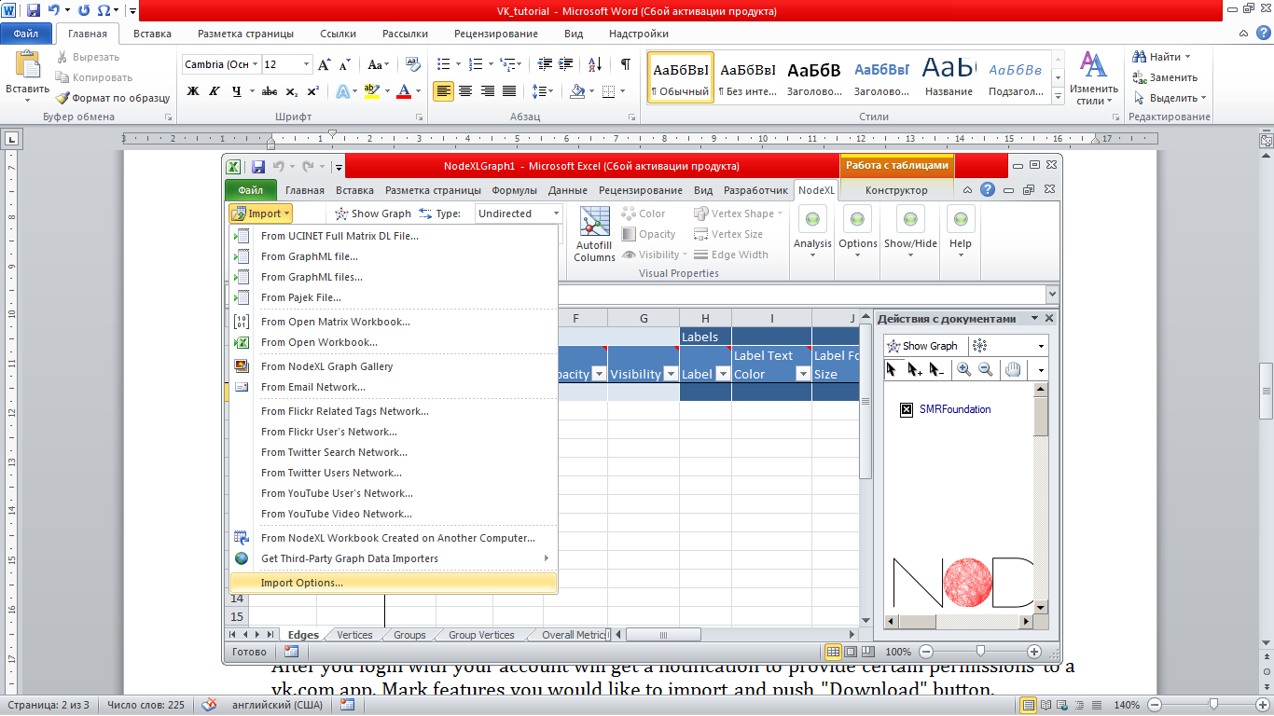

• Browse the folder where you put your .dll files:

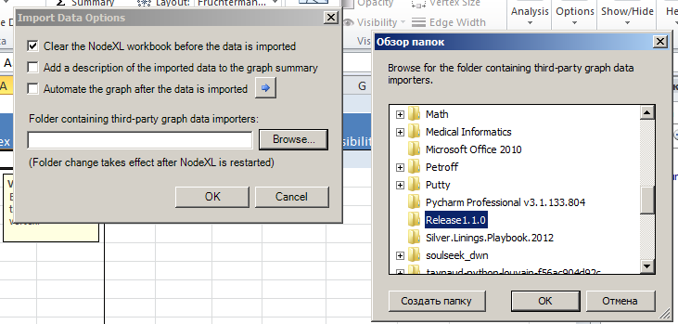

• Restart NodeXL

# 3. Import Ego network from Vkontakte

* Go to NodeXL -> Import -> From Vkontakte network importer:

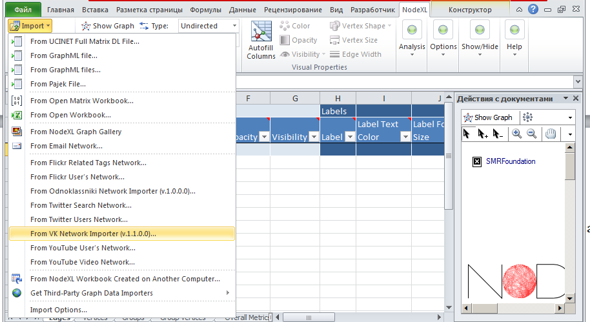

* Login to your vk.com account:

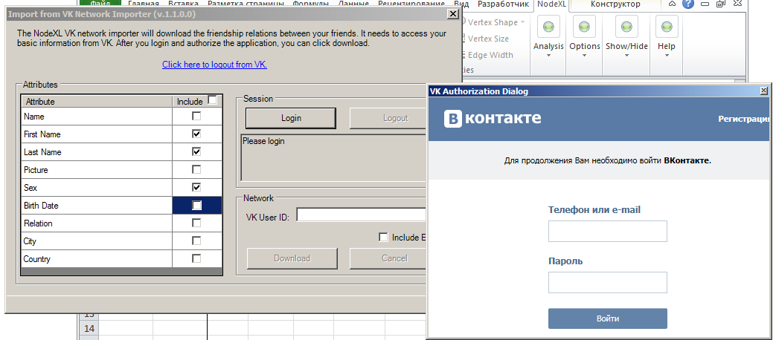

* After you login with your account will get a notification to provide certain permissions to a vk.com app. Mark features you would like to import and push "Download" button:

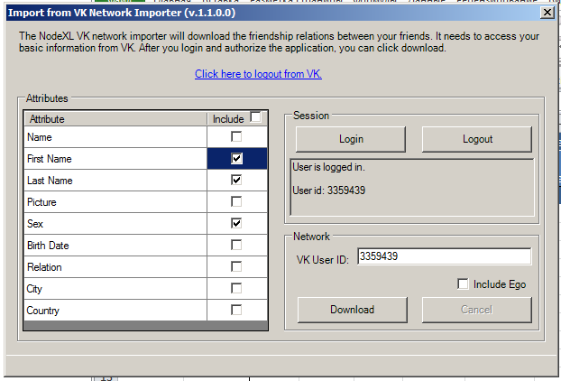

* Finally, export your network to GraphML format to be able to open it with igraph:

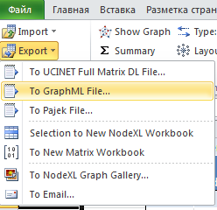

* Done!